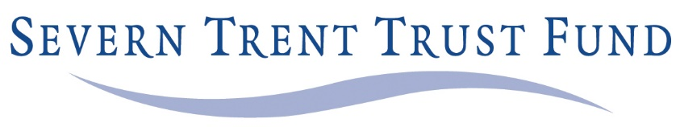

Severn Trent Water Charitable Trust Fund
Remuneration: £0 + expenses
Location: Midlands, meetings in central Birmingham, Sutton Coldfield or on-line
Category: Trustees
Sectors: Debt relief

Job Description
The Severn Trent Trust Fund is a major charity serving the Midlands. Its income last year was £3.5million, donated by Severn Trent Water to help their customers who are experiencing financial hardship.
The Trust, which has been established over 23 years is now looking to recruit a new trustee.
The Trust wholly owns a trading subsidiary Auriga Services Ltd which in addition to managing the Severn Trent Trust Fund, manages the trust funds of Thames Water and United Utilities. It also runs a debt advice and welfare benefits service for various clients including the NHS.
We are looking for people from a wide variety of backgrounds. Specifically, we wish to appoint a candidate with accountancy and financial experience. We would expect the new Trustee to be a member of the Audit & Risk Committee.
We are committed to diversity and inclusion and aim to increase the diversity of the Trustee Board.
Most of all we are looking for people with the time and energy to devote to being responsible trustees to ensure good governance and oversee the running of the trust.
The anticipated time commitment will be 10 to 12 half days. You will need to attend four half day formal meetings per year plus four Audit & Risk meetings, plus other ad-hoc meetings.
Your application should be in the form of you CV and an accompanying letter stating why you would like to be a trustee of this particular trust, and the specific skills that you will bring to add value.
Key information can be found at www.sttf.org.uk and specific guidance and documents about this appointment can be found at https://www.sttf.org.uk/vacancies/
Please apply by Monday 4th January 2021. Interviews by video likely to be week commencing 18th January.
Please send your applications to Mark Abrams, Chief Executive, MAbrams@aurigaservices.co.uk

